Assignment Title:
Conversion of Infix Expression to Postfix and Prefix Using Java
Abstract
This assignment demonstrates how to convert an infix expression into postfix and prefix forms using Java. It includes a detailed workflow represented by a flowchart, pseudocode outlining the algorithm, a complete Java program implementation, and example outputs showing the conversion results.
1. WorkFlow
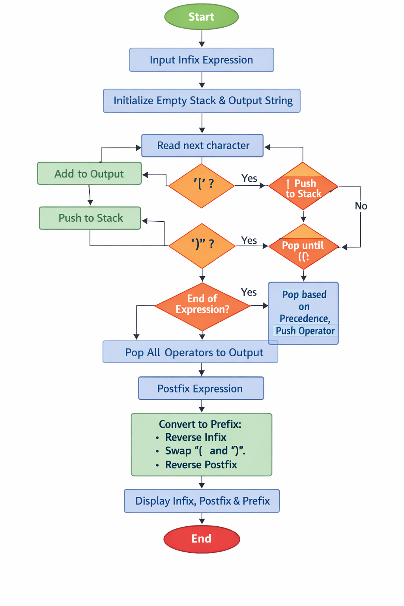
2. Pseudocode
function infixToPostfix(expression):
create empty stack
create empty output string
for each character in expression:
if operand → add to output
if '(' → push to stack
if ')' → pop until '('
if operator → pop higher/equal precedence operators, then push current
pop remaining operators to output
return output

function infixToPrefix(expression):
reverse expression
swap '(' and ')'
postfix = infixToPostfix(reversed expression)
prefix = reverse(postfix)
return prefix
3.Example Conversion
Expression: (A-B/C)*(A/K-L)
- ( → push
- A → output → A
- - → push
- B → output → AB
- / → push (higher precedence than -)
- C → output → ABC
- ) → pop until ‘(‘→ output becomes ABC/-
- * → push
- ( → push
- A → output → ABC/-A
- / → push
- K → output → ABC/-AK
- - → push
- L → output → ABC/-AKL
- ) → pop until ( → output becomes ABC/-AK/L-
- End: pop remaining * → final postfix = ABC/-AK/L-*
- Reverse logic → prefix = *-A/BC-/AKL

5. Example Output (from VS Code terminal)
Infix: (A-B/C)*(A/K-L)
Postfix: ABC/-AK/L-*
Prefix: *-A/BC-/AKL

